MOIRA’S DESKTOP REFERENCE

USING 2182 kHz WITH VOICE
- Push [2182kHz] to select the emergency frequency.
- Push [ALARM] and [TX FREQ] for 1 sec to transmit a 2-tone alarm signal for at least 30 sec.
The transceiver automatically stops the alarm after 50 sec.
- Push [ALARM] to turn the alarm transmisison off, then push and hold the PTT switch on the microphone and send the following information:
  - “MAYDAY, MAYDAY, MAYDAY.”
  - “THIS IS ….” (name of vessel)
  - “LOCATED AT ….” (vessel’s posiiton)
  - Give the reason for the distress call.
  - Explain what assistance you need.
  - Give additional information:
- Vessel type
- Vessel length
- Vessel color
- Number of people onboard
90% charge on 360Ah bank
13.6V | < 14A
13.5 | 12
13.4 | 10.4
13.2 | 7.2
100 % charge on 360Ah bank
14.0V | < 5.4A
13.8 | 4.5
13.6 | 3.6
13.2 | 1.8
12.8 | 0
Resting voltage (Gel)
100% | 12.8V
75 | 12.5
50 | 12.3
25 | 12.0
0 | 11.8

PROGRAMMING A CHANNEL

- Select channel
- Press CE to show frequency
- Enter frequency with keypad
- If necessary select correct MODE
- Press and hold RX 1 sec.
- Press TX so “TX” flashes
- Press CE to show frequency
- Enter frequency with keypad
- Press and hold TX 1 sec.
- Press TX to stop “TX” flashing
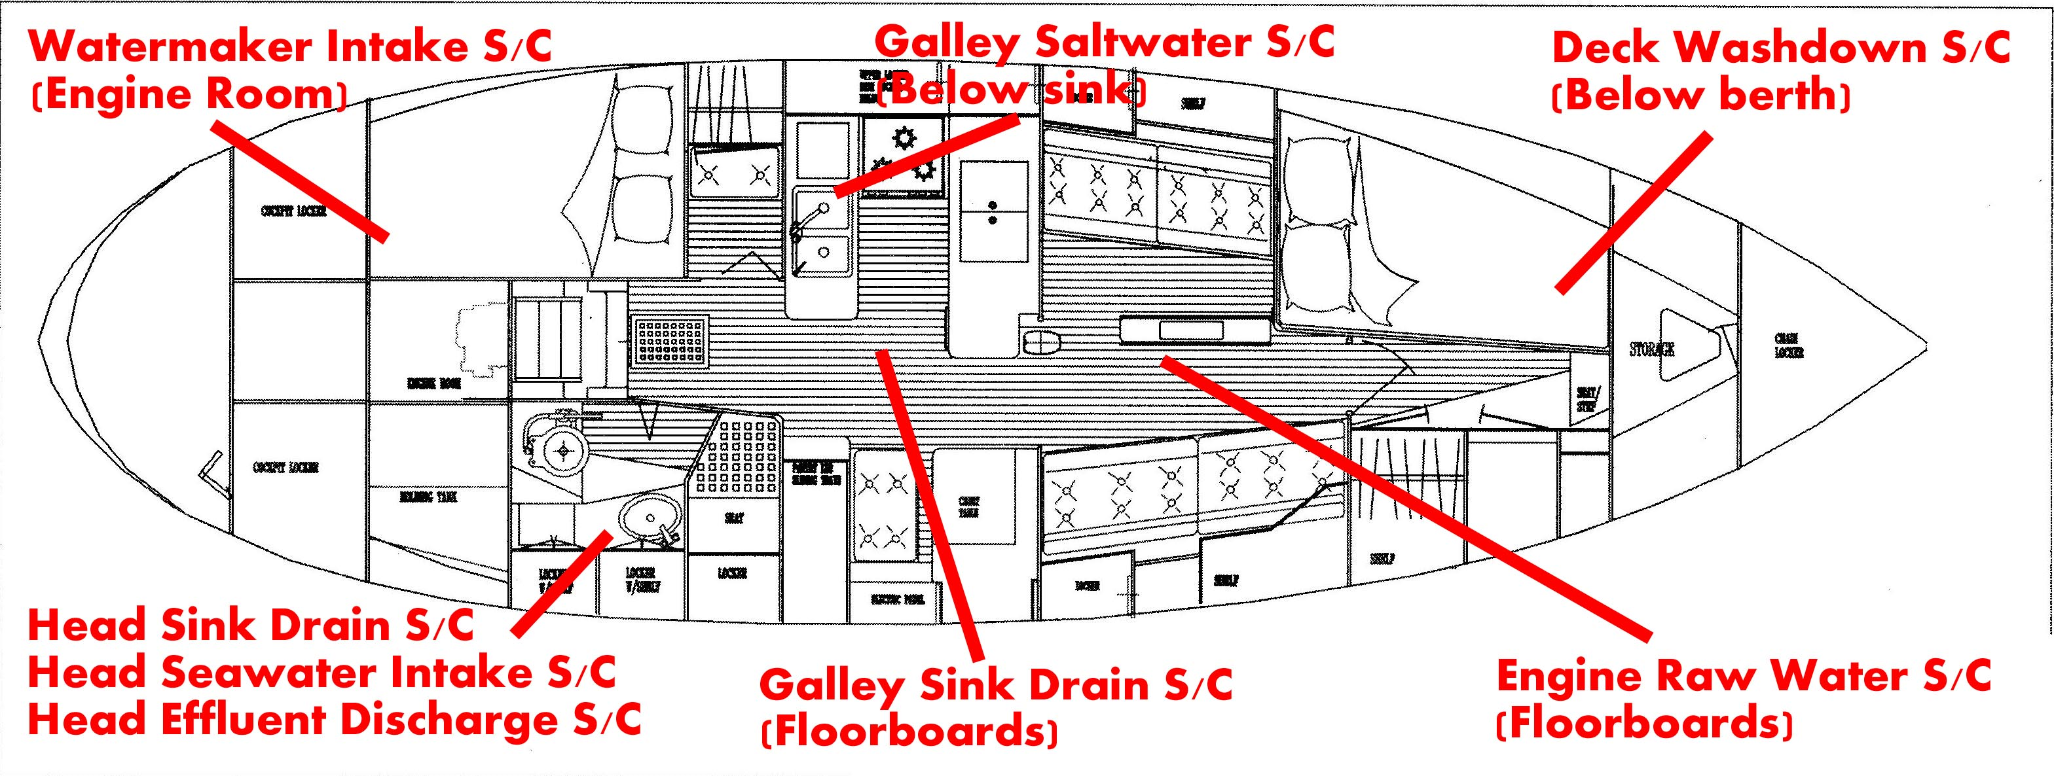

SAFETY CHANNELS
Channel # | Frequency

SAFETY
1 | 2182 kHz
2 | 4125
3 | 6215
4 | 8291
5 | 12290
6 | 16420

USCG
7 | 2670
8 | (RX/TX)  4426/4134
9 | 6501/6200
10 | 8764/8240
11 | 13089/12242
12 | 17314/16432

MMSN
147 | 14300

USCG RCC’s
Miami | (305)415-6800
San Juan | (787)289-2042
Portsmouth | (757)398-6231

Geostrophic Wind Force (after Dashew P.113)

Wind speed (Kts) given latitude and spacing in degrees between 4mb isobars
Degrees Between 4mb Isobars | Latitude of observation
Degrees Between 4mb Isobars | 10 | 20 | 30 | 40 | 50
1 | -- | 78 G 116 | 54 G 80 | 42 G 62 | 36 G 52
2 | 76 G 115 | 39 G 58 | 27 G 40 | 21 G 31 | 18 G 26
3 | 50 G 75 | 26 G 39 | 18 G 26 | 14 G 20 | 12 G 18
4 | 36 G 55 | 19 G 30 | 14 G 20 | 10 G 15 | 9 G 13
5 | 29 G 44 | 16 G 23 | 10 G 16 | 8 G 13 | 7 G 10

Charge curve on 360Ah | 90% Charge | 100% Charge
14.0V | < 18A | < 5.4A
13.8 | 16 | 4.5
13.6 | 14 | 3.6
13.5 | 12 | 3.1
13.4 | 10 | 2.7
13.2 | 7.2 | 1.8
12.8 | 3.6 | 0
Resting voltage (Gel)
100% | 12.8V
75 | 12.5
50 | 12.3
25 | 12.0
0 | 11.8

Leonard, 5.5% bleach (“Clorox”)
- Wash vegs: 1 oz/gal
- Clean tanks 6-8oz/10-15 gal then rinse 3x
- Treat water: 1 1/3-1 2/3 oz/33 gal
D’Antonio
2 cycle oil in diesel: 1/3oz/gal
Speed to Exceed
 | Deviation (Degrees)
Speed Direct | 10 | 20 | 30 | 40 | 50 | 60
2 | 2.0 | 2.1 | 2.3 | 2.6 | 3.1 | 4.0
2.5 | 2.5 | 2.7 | 2.9 | 3.3 | 3.9 | 5.0
3 | 3.0 | 3.2 | 3.5 | 3.9 | 4.7 | 6.0
3.5 | 3.6 | 3.7 | 4.0 | 4.6 | 5.4 | 7.0
4 | 4.1 | 4.3 | 4.6 | 5.2 | 6.2 | 8.0
4.5 | 4.6 | 4.8 | 5.2 | 5.9 | 7.0 | 9.0
5 | 5.1 | 5.3 | 5.8 | 6.5 | 7.8 | 10.0
5.5 | 5.6 | 5.9 | 6.4 | 7.2 | 8.6 | 11.0
6 | 6.1 | 6.4 | 6.9 | 7.8 | 9.3 | 12.0
6.5 | 6.6 | 6.9 | 7.5 | 8.5 | 10.1 | 13.0
7 | 7.1 | 7.4 | 8.1 | 9.1 | 10.9 | 14.0
7.5 | 7.6 | 8.0 | 8.7 | 9.8 | 11.7 | 15.0

